ETL Interview questions

Table a 100 records
Table b 50 records
Matched records 20

Output
Inner join 20
Left join 100
Right join 50
Full join 130
Cross join 500

SELECT COUNT(*) FROM (
SELECT A.EMPNAME , B.EMPNAME FROM A1 A INNER JOIN A2 B
ON A.EMPNAME=B.EMPNAME
)A

SELECT COUNT(*) FROM (
SELECT A.EMPNAME , B.EMPNAME FROM A1 A RIGHT JOIN A2 B
ON A.EMPNAME=B.EMPNAME
)A

SELECT COUNT(*) FROM (
SELECT A.EMPNAME , B.EMPNAME FROM A1 A LEFT JOIN A2 B
ON A.EMPNAME=B.EMPNAME
)A

SELECT COUNT(*) FROM (
SELECT A.EMPNAME , B.EMPNAME FROM A1 A FULL JOIN A2 B
ON A.EMPNAME=B.EMPNAME
)A

SELECT COUNT(*) FROM (
SELECT A.EMPNAME , B.EMPNAME FROM A1 A CROSS JOIN A2 B
ON A.EMPNAME=B.EMPNAME
)A

https://www.softwaretestinghelp.com/unix-interview-questions/

- How to find duplicate records without having and primary key constraint

Answer
select productId , categoryId , state , dateDone , count(*) from your_table
group by productId ,categoryId ,state, dateDone
having count(*) >1

- Percentage of null records in a column
select
count(1) as total, count(comm) as not_null,
count(1)- count(comm) as nullvalues,
100*count(comm)/count (1) as percentage
from emp

- Date functions
- Date function below listed

- https://qurosity.com/oracle-correlated-subquery/
Correlated Subquery in Oracle
In a correlated subquery, the inner subquery refers to an object from outer query.
Before we understand the concept behind correlated subquery, lets revisit the concept of subquery by seeing this example:
SQL
SELECT *
FROM employees
WHERE salary > (SELECT salary
FROM employees
WHERE first_name = 'Den');
This query returns a list of employees who are having salary greater than ‘Den’. The inner subquery gives us the salary of employee named
In this example, the nested subquery is complete in itself and gets executed first before outer query. In case of correlated subquery, the nested query references to the outer query and may need to evaluated once for each row selected by outer query.
Let’s understand this through the following examples:
Oracle Correlated Subquery Example
We will be using Employees table from HR schema for this example:
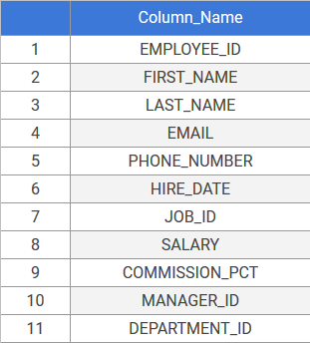
1. Simple Correlated Subquery Example
Suppose, we want to find a list of all employees who are earning more than the average salary of employees in their department, then we use the following query:
SQL
SELECT first_name, salary, department_id
FROM employees e
WHERE salary >
(SELECT AVG(salary)
FROM employees
WHERE department_id =
e.department_id)
ORDER BY salary
Result:
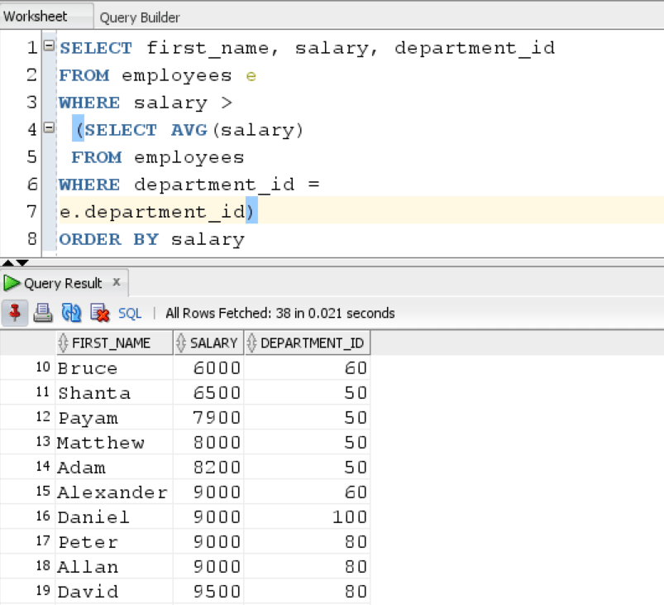
The query returns all the employees who are earning more than the average salary in their department.
In this case, the nested subquery refers to the department_id from outer query for returning a result on a row by row basis. Then the outer query evaluates each row to check whether the employee is earning more than the average salary in his/her department or not. If a row satisfies the condition, then it gets returned in the final output.
Let’s see one more query of this type to get a hang of this concept:
The following query returns a list of all employees who are earning more than the minimum salary offered in their department:
SQL
SELECT first_name, salary, department_id
FROM employees e
WHERE salary >
(SELECT MIN(salary)
FROM employees
WHERE department_id =
e.department_id)
ORDER BY salary
Result:
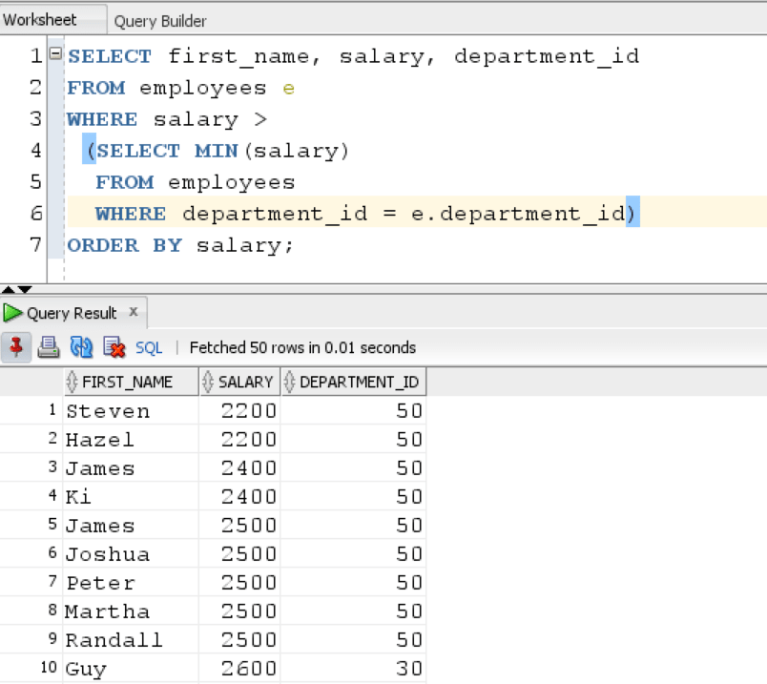
As Oracle needs to constantly move back and forth between the inner and outer query on a row by row basis for evaluating the results, Correlated Subquery can be slow in execution.
2. Correlated Subquery in SELECT clause Example
Suppose, we want to find salary and average salary in an employee ‘s department side by side, then we we use this query:
SQL
SELECT
employee_id,
first_name,
last_name,
salary,
ROUND(
( SELECT
AVG( salary )
FROM
employees
WHERE
department_id = e.department_id
),
3
) avg_salary
FROM
employees p
ORDER BY
salary;
Result:
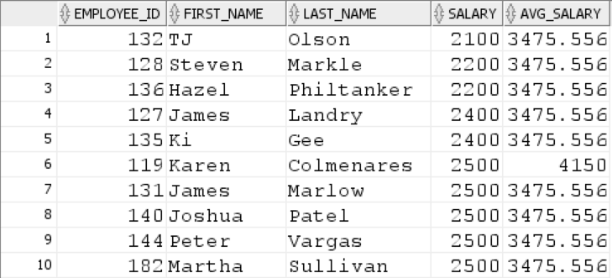
The department ID from nested subquery is referencing to department_id in outer query and it returns employee’s salary and average salary in their department side by side.
3. Correlated Subquery with EXISTS Operator example
The EXISTS operator checks whether any row is found. The nested subquery is used an operand for EXISTS operator. If nested subquery returns some rows, EXISTS operator returns TRUE if it doesn’t then it returns FALSE.
Let’s see one example:
The following correlated subquery returns all departments which have at least one employee working in them.
SQL
SELECT d.department_id, d.department_name
FROM departments d
WHERE EXISTS (SELECT *
FROM employees e
WHERE d.department_id =
e.department_id)
ORDER BY d.department_id
Result:
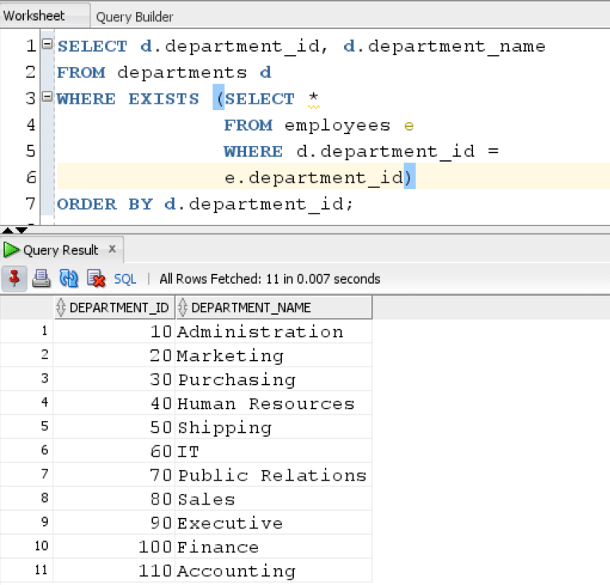
The query returns all departments where at least one employee is working.
Now let’s see a similar example of NOT EXISTS subquery:
Using NOT EXISTS operator gives us all the departments in which there is no one working.
SQL
SELECT d.department_id, d.department_name
FROM departments d
WHERE NOT EXISTS (SELECT *
FROM employees e
WHERE d.department_id =
e.department_id)
ORDER BY d.department_id
Result:
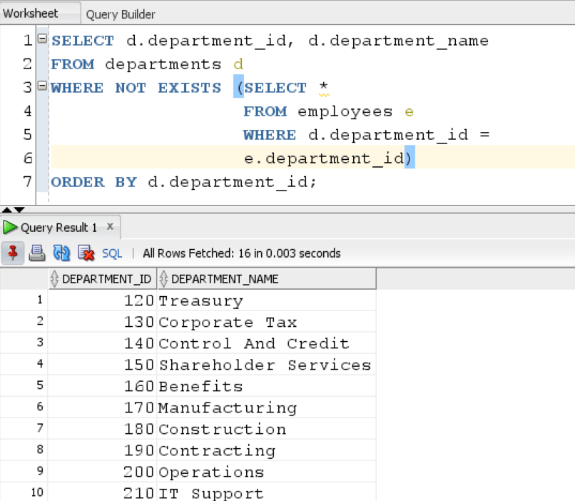
As we can see, the query returned a list of ghost departments in the organization in which no employee works.
In this tutorial, we understood the basics of correlated subquery and learned how to apply it in different use cases.

- Percentage of m and f list from a table
SELECT
COUNT(CASE gender WHEN 'Male' THEN 1 ELSE NULL END) AS male_count,
COUNT(CASE gender WHEN 'Female' THEN 1 ELSE NULL END) AS female_count
FROM PEOPLE

- How to join five tables
5-1

Self join manager example

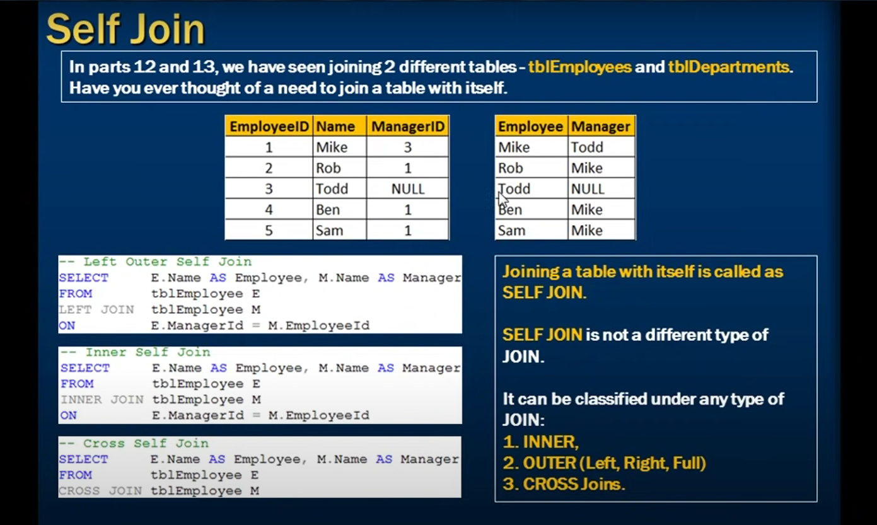

CREATE VIEW AS
SELECT e1.emp_Id EmployeeId, e1.emp_name EmployeeName,
e1.emp_mgr_id ManagerId, e2.emp_name AS ManagerName
FROM tblEmployeeDetails e1
LEFT JOIN tblEmployeeDetails e2
ON e1.emp_mgr_id = e2.emp_id

Oracle SELF JOIN
Self Join is a specific type of Join. In Self Join, a table is joined with itself (Unary relationship). A self join simply specifies that each rows of a table is combined with itself and every other row of the table.
Syntax
- SELECT a.column_name, b.column_name...
- FROM table1 a, table1 b
- WHERE a.common_filed = b.common_field;
Oracle SELF JOIN Example
Let's take a table "customers".
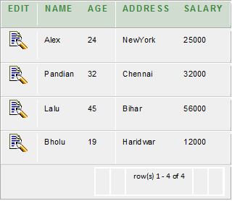
Join this table using SELF JOIN as follows:
PlayNext
Mute
Current Time 0:05
/
Duration 18:10
Loaded: 4.04%

Fullscreen
Backward Skip 10sPlay VideoForward Skip 10s
Advertisement
- SELECT a.name, b.age, a.SALARY
- FROM CUSTOMERS a, CUSTOMERS b
- WHERE a.SALARY < b.SALARY;
Output
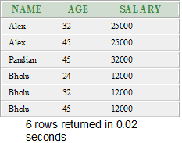

- Retrieve only mismatched records between two tables without using minus or except
Left outer join or right outer joins
- Lead lag functions
https://oracle-base.com/articles/misc/lag-lead-analytic-functions
Setup
The examples in this article require the following table.
--DROP TABLE emp PURGE;

SELECT empno,
ename,
job,
sal,
LEAD(sal, 1, 0) OVER (ORDER BY sal) AS sal_NEXT,
sal,
LAG(sal, 1, 0) OVER (ORDER BY sal) AS sal_prev

-- sal - LAG(sal, 1, 0) OVER (ORDER BY sal) AS sal_diff
FROM emp;

CREATE TABLE emp (
empno NUMBER(4) CONSTRAINT pk_emp PRIMARY KEY,
ename VARCHAR2(10),
job VARCHAR2(9),
mgr NUMBER(4),
hiredate DATE,
sal NUMBER(7,2),
comm NUMBER(7,2),
deptno NUMBER(2)
);

INSERT INTO emp VALUES (7369,'SMITH','CLERK',7902,to_date('17-12-1980','dd-mm-yyyy'),800,NULL,20);
INSERT INTO emp VALUES (7499,'ALLEN','SALESMAN',7698,to_date('20-2-1981','dd-mm-yyyy'),1600,300,30);
INSERT INTO emp VALUES (7521,'WARD','SALESMAN',7698,to_date('22-2-1981','dd-mm-yyyy'),1250,500,30);
INSERT INTO emp VALUES (7566,'JONES','MANAGER',7839,to_date('2-4-1981','dd-mm-yyyy'),2975,NULL,20);
INSERT INTO emp VALUES (7654,'MARTIN','SALESMAN',7698,to_date('28-9-1981','dd-mm-yyyy'),1250,1400,30);
INSERT INTO emp VALUES (7698,'BLAKE','MANAGER',7839,to_date('1-5-1981','dd-mm-yyyy'),2850,NULL,30);
INSERT INTO emp VALUES (7782,'CLARK','MANAGER',7839,to_date('9-6-1981','dd-mm-yyyy'),2450,NULL,10);
INSERT INTO emp VALUES (7788,'SCOTT','ANALYST',7566,to_date('13-JUL-87','dd-mm-rr')-85,3000,NULL,20);
INSERT INTO emp VALUES (7839,'KING','PRESIDENT',NULL,to_date('17-11-1981','dd-mm-yyyy'),5000,NULL,10);
INSERT INTO emp VALUES (7844,'TURNER','SALESMAN',7698,to_date('8-9-1981','dd-mm-yyyy'),1500,0,30);
INSERT INTO emp VALUES (7876,'ADAMS','CLERK',7788,to_date('13-JUL-87', 'dd-mm-rr')-51,1100,NULL,20);
INSERT INTO emp VALUES (7900,'JAMES','CLERK',7698,to_date('3-12-1981','dd-mm-yyyy'),950,NULL,30);
INSERT INTO emp VALUES (7902,'FORD','ANALYST',7566,to_date('3-12-1981','dd-mm-yyyy'),3000,NULL,20);
INSERT INTO emp VALUES (7934,'MILLER','CLERK',7782,to_date('23-1-1982','dd-mm-yyyy'),1300,NULL,10);
COMMIT;
Introduction
Both LAG and LEAD functions have the same usage, as shown below. The analytic clause elements are described in more detail here.
LAG
{ ( value_expr [, offset [, default]]) [ { RESPECT | IGNORE } NULLS ]
| ( value_expr [ { RESPECT | IGNORE } NULLS ] [, offset [, default]] )
}
OVER ([ query_partition_clause ] order_by_clause)

LEAD
{ ( value_expr [, offset [, default]] ) [ { RESPECT | IGNORE } NULLS ]
| ( value_expr [ { RESPECT | IGNORE } NULLS ] [, offset [, default]] )
}
OVER ([ query_partition_clause ] order_by_clause)
- value_expr - Can be a column or a built-in function, except for other analytic functions.
- offset - The number of rows preceeding/following the current row, from which the data is to be retrieved. The default value is 1.
- default - The value returned if the offset is outside the scope of the window. The default value is NULL.
Looking at the EMP table, we query the data in salary (SAL) order.
SELECT empno,
ename,
job,
sal
FROM emp
ORDER BY sal;

EMPNO ENAME JOB SAL
---------- ---------- --------- ----------
7369 SMITH CLERK 800
7900 JAMES CLERK 950
7876 ADAMS CLERK 1100
7521 WARD SALESMAN 1250
7654 MARTIN SALESMAN 1250
7934 MILLER CLERK 1300
7844 TURNER SALESMAN 1500
7499 ALLEN SALESMAN 1600
7782 CLARK MANAGER 2450
7698 BLAKE MANAGER 2850
7566 JONES MANAGER 2975
7788 SCOTT ANALYST 3000
7902 FORD ANALYST 3000
7839 KING PRESIDENT 5000

SQL>
LAG
The LAG function is used to access data from a previous row. The following query returns the salary from the previous row to calculate the difference between the salary of the current row and that of the previous row. Notice that the ORDER BY of the LAG function is used to order the data by salary.
SELECT empno,
ename,
job,
sal,
LAG(sal, 1, 0) OVER (ORDER BY sal) AS sal_prev,
sal - LAG(sal, 1, 0) OVER (ORDER BY sal) AS sal_diff
FROM emp;

EMPNO ENAME JOB SAL SAL_PREV SAL_DIFF
---------- ---------- --------- ---------- ---------- ----------
7369 SMITH CLERK 800 0 800
7900 JAMES CLERK 950 800 150
7876 ADAMS CLERK 1100 950 150
7521 WARD SALESMAN 1250 1100 150
7654 MARTIN SALESMAN 1250 1250 0
7934 MILLER CLERK 1300 1250 50
7844 TURNER SALESMAN 1500 1300 200
7499 ALLEN SALESMAN 1600 1500 100
7782 CLARK MANAGER 2450 1600 850
7698 BLAKE MANAGER 2850 2450 400
7566 JONES MANAGER 2975 2850 125
7788 SCOTT ANALYST 3000 2975 25
7902 FORD ANALYST 3000 3000 0
7839 KING PRESIDENT 5000 3000 2000

SQL>
If the LAG would span a partition boundary, the default value is returned. In the following example we partition by department, so the SAL_PREV column has a default value of "0" for the first row in each department.
SELECT deptno,
empno,
ename,
job,
sal,
LAG(sal, 1, 0) OVER (PARTITION BY deptno ORDER BY sal) AS sal_prev
FROM emp;

DEPTNO EMPNO ENAME JOB SAL SAL_PREV
---------- ---------- ---------- --------- ---------- ----------
10 7934 MILLER CLERK 1300 0
10 7782 CLARK MANAGER 2450 1300
10 7839 KING PRESIDENT 5000 2450
20 7369 SMITH CLERK 800 0
20 7876 ADAMS CLERK 1100 800
20 7566 JONES MANAGER 2975 1100
20 7788 SCOTT ANALYST 3000 2975
20 7902 FORD ANALYST 3000 3000
30 7900 JAMES CLERK 950 0
30 7654 MARTIN SALESMAN 1250 950
30 7521 WARD SALESMAN 1250 1250
30 7844 TURNER SALESMAN 1500 1250
30 7499 ALLEN SALESMAN 1600 1500
30 7698 BLAKE MANAGER 2850 1600

SQL>
LEAD
The LEAD function is used to return data from rows further down the result set. The following query returns the salary from the next row to calculate the difference between the salary of the current row and the following row.
SELECT empno,
ename,
job,
sal,
LEAD(sal, 1, 0) OVER (ORDER BY sal) AS sal_next,
LEAD(sal, 1, 0) OVER (ORDER BY sal) - sal AS sal_diff
FROM emp;

EMPNO ENAME JOB SAL SAL_NEXT SAL_DIFF
---------- ---------- --------- ---------- ---------- ----------
7369 SMITH CLERK 800 950 150
7900 JAMES CLERK 950 1100 150
7876 ADAMS CLERK 1100 1250 150
7521 WARD SALESMAN 1250 1250 0
7654 MARTIN SALESMAN 1250 1300 50
7934 MILLER CLERK 1300 1500 200
7844 TURNER SALESMAN 1500 1600 100
7499 ALLEN SALESMAN 1600 2450 850
7782 CLARK MANAGER 2450 2850 400
7698 BLAKE MANAGER 2850 2975 125
7566 JONES MANAGER 2975 3000 25
7788 SCOTT ANALYST 3000 3000 0
7902 FORD ANALYST 3000 5000 2000
7839 KING PRESIDENT 5000 0 -5000

SQL>
If the LEAD would span a partition boundary, the default value is returned. In the following example we partition by department, so the SAL_NEXT column has a default value of "0" for the last row in each department.
SELECT deptno,
empno,
ename,
job,
sal,
LEAD(sal, 1, 0) OVER (PARTITION BY deptno ORDER BY sal) AS sal_next
FROM emp;

DEPTNO EMPNO ENAME JOB SAL SAL_NEXT
---------- ---------- ---------- --------- ---------- ----------
10 7934 MILLER CLERK 1300 2450
10 7782 CLARK MANAGER 2450 5000
10 7839 KING PRESIDENT 5000 0
20 7369 SMITH CLERK 800 1100
20 7876 ADAMS CLERK 1100 2975
20 7566 JONES MANAGER 2975 3000
20 7788 SCOTT ANALYST 3000 3000
20 7902 FORD ANALYST 3000 0
30 7900 JAMES CLERK 950 1250
30 7654 MARTIN SALESMAN 1250 1250
30 7521 WARD SALESMAN 1250 1500
30 7844 TURNER SALESMAN 1500 1600
30 7499 ALLEN SALESMAN 1600 2850
30 7698 BLAKE MANAGER 2850 0

SQL>

- Aggregate function like sum, average, min, max

- String function like substring in string instr index

select ename, instr(ename,'M')as ee from emp
- What is Hadoop and cloud
- How to validation report
- How to extract date from dashboard and compare with database
- Fact and dimension tables
- What is view and materialled view
- High severity and high priority and low priority and severity example
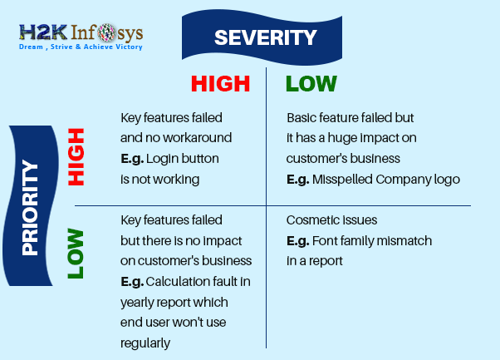
- What kind of sanity checks
- Scd types with examples
- Source target validations
- Sprint planning
- Retrospective meeting
- Cast function
- Duplicate values find and deletion
- Where and having using example
Difference between Where and Having Clause in SQL
Last Updated : 06 Mar, 2024

WHERE and HAVING clauses play an important role in refining the result set of a query. While both clauses are used for filtering data, they serve distinct purposes and are applied at different stages of query execution. Let’s explore the details of each and their differences with examples.
WHERE Clause
WHERE Clause is used to filter the records from the table or used while joining more than one table. Only those records will be extracted who are satisfying the specified condition in the WHERE clause. It can be used with SELECT, UPDATE, and DELETE statements. It is applied before any grouping or aggregation occurs in a query
Let us consider the below table “Student”
Roll_no | S_Name | Age
1 | a | 17
2 | b | 20
3 | c | 21
4 | d | 18
5 | e | 20
6 | f | 17
7 | g | 21
8 | h | 17
Query:
SELECT S_Name, Age FROM Student
WHERE Age >=18
OUTPUT:
S_Name | Age
b | 20
c | 21
d | 18
e | 20
g | 21
HAVING Clause
HAVING Clause is used to filter the records from the groups based on the given condition in the HAVING Clause. Those groups who will satisfy the given condition will appear in the final result. It is applied after the grouping and aggregation of data.
Let us consider Student table mentioned above and apply having clause on it:
SELECT Age, COUNT(Roll_No) AS No_of_Students
FROM Student GROUP BY Age
HAVING COUNT(Roll_No) > 1
OUTPUT:
Age | No_of_Students
17 | 3
20 | 2
21 | 2
Difference Between Where and Having Clause in SQL
SR.NO. | WHERE Clause | HAVING Clause
1. | Filters rows before groups are aggregated. | Filters groups after the aggregation process..
2. | WHERE Clause can be used without GROUP BY Clause | HAVING Clause can be used with GROUP BY Clause
3. | WHERE Clause implements in row operations | HAVING Clause implements in column operation
4. | WHERE Clause cannot contain aggregate function | HAVING Clause can contain aggregate function
5. | WHERE Clause can be used with SELECT, UPDATE, DELETE statement. | HAVING Clause can only be used with SELECT statement.
6. | WHERE Clause is used before GROUP BY Clause | HAVING Clause is used after GROUP BY Clause
7. | WHERE Clause is used with single row function like UPPER, LOWER etc. | HAVING Clause is used with multiple row function like SUM, COUNT etc.

- 2nd highest salary finding
SELECT * FROM (
SELECT emp_name, emp_salary, DENSE_RANK() OVER (ORDER BY emp_salary DESC) AS r
FROM emp
) AS subquery
WHERE r = 3;

ANOTHER METHOD

with highsal as
(
select ename, job, mgr, sal, dense_rank() over(order by sal desc)as abc
from emp
)
select * from highsal where sll=3

- All joins
- Rank dense rank row number
- SELECT empno,
- ename,
- deptno,
- sal,
- ROW_NUMBER() OVER (ORDER BY sal) AS row_num,
- RANK() OVER (ORDER BY sal) AS row_rank,
- DENSE_RANK() OVER (ORDER BY sal) AS row_dense_rank
- FROM emp;

- EMPNO ENAME DEPTNO SAL ROW_NUM ROW_RANK ROW_DENSE_RANK
- ---------- ---------- ---------- ---------- ---------- ---------- --------------
- 7369 SMITH 20 800 1 1 1
- 7900 JAMES 30 950 2 2 2
- 7876 ADAMS 20 1100 3 3 3
- 7521 WARD 30 1250 4 4 4
- 7654 MARTIN 30 1250 5 4 4
- 7934 MILLER 10 1300 6 6 5
- 7844 TURNER 30 1500 7 7 6
- 7499 ALLEN 30 1600 8 8 7
- 7782 CLARK 10 2450 9 9 8
- 7698 BLAKE 30 2850 10 10 9
- 7566 JONES 20 2975 11 11 10
- 7788 SCOTT 20 3000 12 12 11
- 7902 FORD 20 3000 13 12 11
- 7839 KING 10 5000 14 14 12

https://oracle-base.com/articles/misc/rank-dense-rank-first-last-analytic-functions#rank

create table emp (
empno number(4) constraint pk_emp primary key,
ename varchar2(10),
job varchar2(9),
mgr number(4),
hiredate date,
sal number(7,2),
comm number(7,2),
deptno number(2)
);

insert into emp values (7369,'SMITH','CLERK',7902,to_date('17-12-1980','dd-mm-yyyy'),800,null,20);
insert into emp values (7499,'ALLEN','SALESMAN',7698,to_date('20-2-1981','dd-mm-yyyy'),1600,300,30);
insert into emp values (7521,'WARD','SALESMAN',7698,to_date('22-2-1981','dd-mm-yyyy'),1250,500,30);
insert into emp values (7566,'JONES','MANAGER',7839,to_date('2-4-1981','dd-mm-yyyy'),2975,null,20);
insert into emp values (7654,'MARTIN','SALESMAN',7698,to_date('28-9-1981','dd-mm-yyyy'),1250,1400,30);
insert into emp values (7698,'BLAKE','MANAGER',7839,to_date('1-5-1981','dd-mm-yyyy'),2850,null,30);
insert into emp values (7782,'CLARK','MANAGER',7839,to_date('9-6-1981','dd-mm-yyyy'),2450,null,10);
insert into emp values (7788,'SCOTT','ANALYST',7566,to_date('13-JUL-87','dd-mm-rr')-85,3000,null,20);
insert into emp values (7839,'KING','PRESIDENT',null,to_date('17-11-1981','dd-mm-yyyy'),5000,null,10);
insert into emp values (7844,'TURNER','SALESMAN',7698,to_date('8-9-1981','dd-mm-yyyy'),1500,0,30);
insert into emp values (7876,'ADAMS','CLERK',7788,to_date('13-JUL-87', 'dd-mm-rr')-51,1100,null,20);
insert into emp values (7900,'JAMES','CLERK',7698,to_date('3-12-1981','dd-mm-yyyy'),950,null,30);
insert into emp values (7902,'FORD','ANALYST',7566,to_date('3-12-1981','dd-mm-yyyy'),3000,null,20);
insert into emp values (7934,'MILLER','CLERK',7782,to_date('23-1-1982','dd-mm-yyyy'),1300,null,10);
commit;
RANK Analytic Function
The basic description for the RANK analytic function is shown below. The analytic clause is described in more detail here.
RANK() OVER ([ query_partition_clause ] order_by_clause)
Let's assume we want to assign a sequential order, or rank, to people within a department based on salary, we might use the RANK function like this.
select empno,
deptno,
sal,
rank() over (partition by deptno order by sal) as myrank
from emp;

EMPNO DEPTNO SAL MYRANK
---------- ---------- ---------- ----------
7934 10 1300 1
7782 10 2450 2
7839 10 5000 3
7369 20 800 1
7876 20 1100 2
7566 20 2975 3
7788 20 3000 4
7902 20 3000 4
7900 30 950 1
7654 30 1250 2
7521 30 1250 2
7844 30 1500 4
7499 30 1600 5
7698 30 2850 6

SQL>
What we see here is where two people have the same salary they are assigned the same rank. When multiple rows share the same rank the next rank in the sequence is not consecutive. This is like olympic medaling in that if two people share the gold, there is no silver medal etc.
The fact we can rank the rows in the department means we are able to do a Top-N query on a per-department basis. The example below assigns the rank in the inline view, then uses that rank to restrict the rows to the bottom 2 (worst paid) employees in each department.
select *
from (select empno,
deptno,
sal,
rank() over (partition by deptno order by sal) as myrank
from emp)
where myrank <= 2;

EMPNO DEPTNO SAL MYRANK
---------- ---------- ---------- ----------
7934 10 1300 1
7782 10 2450 2
7369 20 800 1
7876 20 1100 2
7900 30 950 1
7521 30 1250 2
7654 30 1250 2

SQL>
DENSE_RANK Analytic Function
The basic description for the DENSE_RANK analytic function is shown below. The analytic clause is described in more detail here.
DENSE_RANK() OVER([ query_partition_clause ] order_by_clause)
The DENSE_RANK function acts like the RANK function except that it assigns consecutive ranks, so this is not like olympic medaling.
select empno,
deptno,
sal,
dense_rank() over (partition by deptno order by sal) as myrank
from emp;

EMPNO DEPTNO SAL MYRANK
---------- ---------- ---------- ----------
7934 10 1300 1
7782 10 2450 2
7839 10 5000 3
7369 20 800 1
7876 20 1100 2
7566 20 2975 3
7788 20 3000 4
7902 20 3000 4
7900 30 950 1
7654 30 1250 2
7521 30 1250 2
7844 30 1500 3
7499 30 1600 4
7698 30 2850 5

SQL>
As with the RANK analytic function, we can do a Top-N query on a per-department basis. The example below assigns the dense rank in the inline view, then uses that rank to restrict the rows to the top 2 (best paid) employees in each department.
select *
from (select empno,
deptno,
sal,
dense_rank() over (partition by deptno order by sal desc) as myrank
from emp)
where myrank <= 2;

EMPNO DEPTNO SAL MYRANK
---------- ---------- ---------- ----------
7839 10 5000 1
7782 10 2450 2
7788 20 3000 1
7902 20 3000 1
7566 20 2975 2
7698 30 2850 1
7499 30 1600 2

SQL>
RANK Aggregate Function
The RANK function can also be used as an aggregate function to predict the ranking of a new value in an existing result set. Lets assume our salary is 2000, and we want to know where we would rank in the company from lowest to highest. We would use 2000 as a parameter to the RANK function, and use WITHIN GROUP to indicate is is an aggregate function. The lack of the GROUP BY clause means the whole result set is considered a single group.
select rank(2000) within group (order by sal) as row_rank
from emp;

ROW_RANK
----------
9

SQL>
We can see a salary of 2000 would put us at rank 9 in list of lowest to highest salaries.
We can find our rank within a department by adding the DEPTNO column to the select list, and including a GROUP BY clause based on DEPTNO.
select deptno,
rank(2000) within group (order by sal) as row_rank
from emp
group by deptno
order by deptno;

DEPTNO ROW_RANK
---------- ----------
10 2
20 3
30 6

SQL>
DENSE_RANK Aggregate Function
The DENSE_RANK function can also be used as an aggregate function to predict the ranking of a new value in an existing result set. Lets assume our salary is 2000, and we want to know where we would rank in the company from lowest to highest. We would use 2000 as a parameter to the DESNE_RANK function, and use WITHIN GROUP to indicate is is an aggregate function. The lack of the GROUP BY clause means the whole result set is considered a single group.
select dense_rank(2000) within group (order by sal) as row_rank
from emp;

ROW_RANK
----------
8

SQL>
We can see a salary of 2000 would put us at rank 8 in list of lowest to highest salaries.
We can find our rank within a department by adding the DEPTNO column to the select list, and including a GROUP BY clause based on DEPTNO.
select deptno,
dense_rank(2000) within group (order by sal) as row_rank
from emp
group by deptno
order by deptno;

DEPTNO ROW_RANK
---------- ----------
10 2
20 3
30 5

SQL>

- How to fetch 50% records from the table
- String length
- Union and union all
- Intersect minus except
- Types of schemas
- How to fetch the domain name alone
SELECT SUBSTRING((EMAIL), CHARINDEX('@',(EMAIL))+1,LEN((EMAIL))) AS DOMAIN FROM MAIL

- Dwh concept
- Olap and oltp difference.
- How to find special characters
SELECT column FROM table WHERE column REGEXP '[^A-Za-z]'
SELECT TRANSLATE(NAME,'!@#$%^&*()', ' ') FROM EMPLOYEE

SELECT REGEXP_REPLACE(NAME, '[^0-9A-Za-z]', '')
FROM EMPLOYEE

- Pivot table

DATE FUNCTIONS

Skip to content

- Home
- Start Here
- Courses
- Resources
- About
- Contact

Search
- Oracle
- SQL Server
- MySQL
- PostgreSQL
- Database Design
- Career
Oracle Date Functions: The Complete Guide
7 Comments / Last updated: May 27, 2023
There are many different date and time functions in Oracle, and they behave differently than other databases. Learn what they are and see some useful queries in this article.
Oracle date functions are any functions that work with date and/or time values. They often take dates as an input and return many different types of output.
I’ll explain what each of the Oracle date functions is and show an example.
Let’s start by taking a look at the different date-related data types in Oracle.

Table of Contents
- Date and Time Data Types in Oracle
- SYSDATE Function
- CURRENT_DATE
- SYSTIMESTAMP
- CURRENT_TIMESTAMP
- LOCALTIMESTAMP
- ADD_MONTHS
- LAST_DAY
- NEXT_DAY
- MONTHS_BETWEEN
- ROUND
- TRUNC
- EXTRACT
- TO_DATE
- NEW_TIME
- FROM_TZ
- SYS_EXTRACT_UTC
- SESSIONTIMEZONE
- DBTIMEZONE
- Formatting Dates
- Date Format Parameters
- Common Uses for Date Functions
- Conclusion
Date and Time Data Types in Oracle
There are a few different data types in Oracle that store date values. They are:
- DATE: The “standard” date value in Oracle. It stores year, month, day, as well as hour, minute and second. Yes, even though it’s called “date”, it stores the time component. This is a good thing to remember.
- TIMESTAMP: This data type stores year, month, day, hour, minute, second, as well as fractional seconds.
- TIMESTAMP WITH TIME ZONE: This data type is the same as TIMESTAMP, but it stores the timezone along with it.
- TIMESTAMP WITH LOCAL TIME ZONE: This data type is similar to TIMESTAMP WITH TIME ZONE, but the timezone that’s stored is the database timezone.
- INTERVAL YEAR TO MONTH: This data type stores a “period of time” (rather than a “point in time” like other data types), and represents a period of time in months up to years.
- INTERVAL DAY TO SECOND: This data type also stores a period of time, but stores a value that captures seconds all the way up to days.
So now we’ve looked at the different data types, let’s take a look at the different Oracle date functions.
Get Your SQL Cheat Sheet
Download the SQL Cheat Sheets: common commands and syntax - to save you time.
You'll get them for Oracle, SQL Server, MySQL, and PostgreSQL.
Print them or use them as an easy reference.

GET MY CHEAT SHEET

SYSDATE Function
The Oracle SYSDATE function allows you to easily output the current date. It shows the date and time of the database server.
To use it, you simply type the word SYSDATE. It has no parameters, which means you don’t need any brackets after it.
An example of the SYSDATE function is:
SELECT SYSDATE
FROM dual;
Result:
10/SEP/22
I’ve used the DUAL table because Oracle needs to select from a table in a select query, and the DUAL table is useful for this (read more about the dual table here).
As you can see, the current date is shown. It only shows the date, though. This is because the output format for SELECT queries for dates is currently set to the DD/MM/YYYY format.
The SYSDATE function does return the time component as well though. We can see this if we change the session’s date format, or surround the SYSDATE in a TO_CHAR function.
ALTER SESSION
SET NLS_DATE_FORMAT = 'YYYY-MM-DD HH24:MI:SS';
Now, let’s rerun the SELECT statement with the SYSDATE function.
SELECT SYSDATE
FROM dual;
Result:
2022-09-10 08:54:19
As you can see, the output now shows the date and time returned from SYSDATE. We changed the date format in the session to include the time.
We could use the TO_CHAR function to change the way this particular function is shown:
SELECT
TO_CHAR(SYSDATE, 'DD/MM/YYYY HH:MI:SS') AS sysdate_time
FROM dual;
Result:
10/09/2022 08:54:19
You can see that the output now includes the date and time.

CURRENT_DATE
The CURRENT_DATE function is similar to the SYSDATE function, but it shows you the current date and time in the session timezone.
This is the timezone that your session is in, or the timezone you’re in when you log in to the system. This can sometimes be different to the database timezone.
To use this function, simply add the word CURRENT_DATE to your query. No brackets are needed as there are no parameters.
SELECT CURRENT_DATE
FROM dual;
Result:
10/SEP/22
This shows the current date of your user session.
Just like with the SYSDATE function, this function returns a DATE data type, which actually includes a date and a time. To show the time component of this value, either use the TO_CHAR function or alter your session to include the time format.
ALTER SESSION SET NLS_DATE_FORMAT = 'YYYY-MM-DD HH24:MI:SS';
The other way is to use the TO_CHAR function to change the format.
SELECT
TO_CHAR(CURRENT_DATE, 'DD/MM/YYYY HH:MI:SS')
FROM dual;
Result:
10/09/2022 08:54:19
You can see that the output now includes the date and time.

Oracle CURRENT_DATE Vs SYSDATE
The main difference between CURRENT_DATE and SYSDATE is:
- CURRENT_DATE returns the date from your session timezone (your timezone).
- SYSDATE returns the date from the database timezone.
If you’re in the east coast of the United States and your database is on the west coast, these functions will show different values. If you’re in Australia and the database is in London, they will show different values.
They might even look the same but actually be different.
This is because the default output is DD-MON-YY, which hides the time.
This is the default output, assuming I’m in Melbourne (UTC +10) and the database is in Perth (UTC +8).
SELECT CURRENT_DATE, SYSDATE
FROM dual;
Result:
CURRENT_DATE | SYSDATE
10/SEP/22 | 10/SEP/22
These values look the same, right?
Now, if I include the time component by using TO_CHAR, my result shows these two values as being different.
SELECT
TO_CHAR(CURRENT_DATE, 'DD-MON-YY HH:MI:SS') AS CDATE,
TO_CHAR(SYSDATE, 'DD-MON-YY HH:MI:SS') AS SDATE
FROM dual;
Result:
CDATE | SDATE
10-SEP-22 05:53:33 | 10-SEP-22 03:53:33

How Can I Get the Oracle CURRENT_DATE – 1 Day?
If you want to find records that are less than, greater than, or equal to the day before today (or any comparison, really), then you can do this with the Oracle CURRENT_DATE function.
You’ll just have to use TRUNC as well.
SELECT
CURRENT_DATE,
TRUNC(CURRENT_DATE) AS trunc_today,
TRUNC(CURRENT_DATE)-1 AS trunc_yesterday
FROM dual;
Result:
CURRENT_DATE | TRUNC_TODAY | TRUNC_YESTERDAY
10/SEP/22 | 10/SEP/22 | 09/SEP/22

You can use this TRUNC(CURRENT_DATE)-1 logic in your other SQL queries:
--Find employees hired yesterday or later.
SELECT name
FROM employee
WHERE hire_date >= TRUNC(CURRENT_DATE)-1

SYSTIMESTAMP
The SYSTIMESTAMP function returns the date and time of the database.
The important part to remember is that it returns the time of the database, not your local time.
So, if you’re accessing a database in a different time zone, it will return the time and timezone of the place where the database is stored, not your local time zone.
For example, if your database is in London but you are in New York, the SYSTIMESTAMP will return a time that is 5 hours ahead of your time.
It’s similar to the SYSDATE function, however it returns a TIMESTAMP WITH TIME ZONE instead of a DATE data type.
This means it includes the date, time, and fractional seconds.
SELECT SYSTIMESTAMP
FROM dual;
Result:
10/SEP/22 08:57:17.067000000 AM +10:00
Now, because it’s a TIMESTAMP WITH TIME ZONE, it shows the time by default, unlike the DATE data type.
You can see the output here shows the date, the time, the fractions of seconds, and the timezone. You don’t need to format it to see the complete output.

How Can I Insert With SYSTIMESTAMP?
You can insert the value returned by SYSTIMESTAMP in a few ways.
First, you can ensure that the column you’re inserting into is of type TIMESTAMP WITH TIME ZONE.
Alternatively, if it isn’t, you can use the TO_CHAR function to convert the value into a VARCHAR2 data type, and insert that.
However, it’s generally not a good idea to insert dates into character fields. I would recommend inserting the value as a TIMESTAMP WITH TIME ZONE.

Can I Find the SYSTIMESTAMP Without Timezone?
Yes, you can.
You can use SYSDATE to just get the date and time, but it won’t have fractional seconds.

Can I Use TO_CHAR With SYSTIMESTAMP?
Yes, you can. See the Examples below for more information.
You can include the SYSTIMESTAMP function inside TO_CHAR, and specify the format of the values to output.

Example 1
This is the SYSDATE and SYSTIMESTAMP function side-by-side.
SELECT
SYSDATE,
SYSTIMESTAMP
FROM dual;
Result:
SYSDATE | SYSTIMESTAMP
10/SEP/2022 | 10/SEP/22 09:35:48.801000000 AM +11:00

Example 2
This example uses the TO_CHAR function on SYSTIMESTAMP.
SELECT
SYSTIMESTAMP,
TO_CHAR(SYSTIMESTAMP, 'dd Mon yyyy') AS text_output
FROM dual;
Result:
SYSTIMESTAMP | TEXT_OUTPUT
10/SEP/22 09:36:18.196000000 AM +11:00 | 10 Sep 2022

CURRENT_TIMESTAMP
The CURRENT_TIMESTAMP function returns the date and time in the timezone of your session, or where you have logged in from.
It’s similar to the CURRENT_DATE function in that it returns the date and time of your session, instead of the database. It’s also similar to the SYSTIMESTAMP function in that it returns the timestamp instead of a date.
The return data type is a TIMESTAMP WITH TIME ZONE, which includes date, time, fractional seconds, and a timezone.
The CURRENT_TIMESTAMP has one optional parameter: the precision or number of fractional seconds to return. If omitted, it uses 6 places.
CURRENT_TIMESTAMP([precision])
An example of this function is:
SELECT CURRENT_TIMESTAMP
FROM dual;
Result:
10/SEP/22 08:57:49.020000000 AM AUSTRALIA/MELBOURNE
You can see that the current date and time are shown here, along with the timezone.

Can I Subtract Hours from the CURRENT_TIMESTAMP?
Yes, you can. The best way to do this is to use an interval data type, as you’ll keep your original data type.
For example, if I wanted to subtract 4 hours from the current time, I would do this:
SELECT
CURRENT_TIMESTAMP,
CURRENT_TIMESTAMP - INTERVAL '4' HOUR
FROM dual;
Result:
CURRENT_TIMESTAMP | CURRENT_TIMESTAMP-INTERVAL
10/SEP/22 06:17:25.690000000 AM AUSTRALIA/SYDNEY | 10/SEP/22 02:17:25.690000000 AM AUSTRALIA/SYDNEY

LOCALTIMESTAMP
The final function that gets the current date is the LOCALTIMESTAMP function.
This function gets the current date and time of your session.
It’s similar to the CURRENT_TIMESTAMP function, but LOCALTIMESTAMP returns a TIMESTAMP value and CURRENT_TIMESTAMP returns a TIMESTAMP WITH TIME ZONE VALUE.
This means that LOCALTIMESTAMP returns just the date and time, and no timezone.
The LOCALTIMESTAMP function looks like this:
SELECT LOCALTIMESTAMP
FROM dual;
Result:
10/SEP/22 08:58:25.614000000 AM
You can see that the output shows the date, time, and fractional seconds.
The parameters of the LOCALTIMESTAMP function are:
- timestamp_precision (mandatory): This specifies the number of digits of seconds of the return value, also known as the “fractional second precision”.

ADD_MONTHS
The ADD_MONTHS function allows you to input a date value, and a number of months, and return another date value. The value returned is the input date value plus the number of months you supply.
So, if you start with Jan 10th 2022, and add 3 months, the function will return Apr 10th, 2022.
The syntax is:
ADD_MONTHS (input_date, number_of_months)
An example of this function is:
SELECT
SYSDATE,
ADD_MONTHS(SYSDATE, 5) AS new_date
FROM dual;
SYSDATE | NEW_DATE
10/SEP/22 | 10/FEB/23
This query shows the SYSDATE, as well as the SYSDATE with 5 months added. You can see that it has the same day, but it is 5 months in the future.
You can also provide negative values:
SELECT
SYSDATE,
ADD_MONTHS(SYSDATE, -12) AS new_date
FROM dual;
SYSDATE | NEW_DATE
10/SEP/22 | 10/SEP/21
This will show a date of 12 months in the past.
For more information on using the ADD_MONTHS function, including some “what if” questions, read this article: Oracle ADD_MONTHS Function with Examples.

LAST_DAY
The LAST_DAY function returns the last day of the month of the specified date value.
You supply a date, and another date is returned which is the last day of the month.
The syntax is:
LAST_DAY (input_date)
Let’s see an example:
SELECT
SYSDATE,
LAST_DAY(SYSDATE) AS last_of_month
FROM dual;
SYSDATE | LAST_OF_MONTH
10/SEP/22 | 30/22
You can see here that I’ve shown today’s date using SYSDATE, and also the last day of this month using the LAST_DAY function.
What if I wanted to specify a particular date?
You can do that as well, by entering the date in the database’s default format (usually DD-MON-YY) or using the TO_DATE function.
SELECT
LAST_DAY('03-OCT-2022')
FROM dual;
Result:
31/OCT/2022
For more information on the LAST_DAY function, such as returning the first day of the next month (and other examples), read my article: Oracle LAST_DAY Function with Examples.

NEXT_DAY
The NEXT_DAY function returns the date of the next specified weekday that comes after the specified value.
It’s handy for working with any business logic you have where you need to use weekdays.
It takes two parameters:
NEXT_DAY (input_date, weekday)
The input date is the date to start from, and the weekday is the name of the day you’re looking for.
For example, running SYSDATE on today’s date will show 15 Sep 2022, and it’s a Tuesday.
To find the next Thursday that appears after today, use this function:
SELECT
NEXT_DAY(SYSDATE, 'THURSDAY')
FROM dual;
Result:
15/SEP/22
You can see it shows a date of 15th September, which is the next Thursday that comes after the date I mentioned.
If I want to find the next Monday, I change the function slightly:
SELECT
NEXT_DAY(SYSDATE, 'MONDAY')
FROM dual;
Result:
12/SEP/22
You can see it shows a date of 12th September, which is next Monday. It doesn’t show the day before, even though it’s closer. It always goes forwards.
For more information on the NEXT_DAY function, read my article here: Oracle NEXT_DAY Function with Examples.

MONTHS_BETWEEN
The MONTHS_BETWEEN function allows you to find the number of months between two specified dates.
You specify two dates as parameters, and a number is returned:
MONTHS_BETWEEN (date1, date2)
Date1 is usually the later date.
If date1 is greater than date2, the value is positive. Otherwise, it is negative.
The returned value can be a whole or a decimal number. So, it returns a partial month value.
Let’s see an example:
SELECT
MONTHS_BETWEEN('12-MAY-2022', '10-FEB-2022')
FROM dual;
Result:
3.064516129
The value returned is 3.06 because there is approximately 3.06 months between these two dates.

ROUND
The ROUND function allows you to round a date value to a format you specify.
This function is often used with numbers, but can also be used with dates.
If you use it with a date value, you can specify a DATE or TIMESTAMP value. You can specify any format mask, but the default is the nearest day, and is returned as a DATE.
The syntax is:
ROUND (input_date, round_to)
If I wanted to round a date to the nearest month, I would use something like this:
SELECT
ROUND(SYSDATE, 'MM')
FROM dual;
Result:
01/SEP/22
This shows a value of 1 Sep because the specified date (SYSDATE, or 10 Sep) has been rounded forwards to this date.
If we specify a different date and input:
SELECT
ROUND(SYSDATE, 'YYYY')
FROM dual;
Result:
01/JAN/23
We can see that the date shown is 1 Jan 2023. This is because it has rounded forward to the nearest year, and in this case, it is the start of 2023.
For more information on the ROUND function, read my article: SQL ROUND Function with Examples.

TRUNC
The TRUNC function, like the round function, works with numbers as well as dates.
It truncates or removes a part of the date to the format you specify.
The syntax is:
TRUNC (input_date, format_mask)
If you don’t specify a format mask, then the function will truncate the value to the nearest day. This is helpful if you want to remove the time part of a date value.
For example, to show only the date part of today’s date:
SELECT
TRUNC(SYSDATE)
FROM dual;
Result:
10/SEP/22
This shows only the date part of today.
Or, you can show only the YEAR:
SELECT
TRUNC(SYSDATE, 'YYYY')
FROM dual;
Result:
01/JAN/22
You can see that a date is shown that matches the first day of the current year.
For more information on the TRUNC function, read my article here: Oracle TRUNC Function with Examples.

EXTRACT
The EXTRACT function in Oracle extracts a specific part of a date from a date or interval value.
This means that it can get the month, or year, for example, from a DATE value. I think it’s easier than using a conversion function such as TO_CHAR.
The EXTRACT function looks like this:
EXTRACT (date_component FROM expression)
The date_component is a keyword that represents the part of the date to extract, such as MONTH, DAY, YEAR, or HOUR.
The expression is a value or column that is a date or interval data type.
An example of this function is:
SELECT
SYSDATE,
EXTRACT(MONTH FROM SYSDATE) AS extract_month
FROM dual;
SYSDATE | EXTRACT_MONTH
10/SEP/22 | 9
This shows the month part of the SYSDATE.
For more information on the EXTRACT function, you can read my article here: Oracle EXTRACT Function with Examples.

TO_DATE
The TO_DATE function allows you to convert a character value into a date value. It converts any character data type (CHAR, VARCHAR2, NCHAR, or NVARCHAR2) into a DATE type.
It’s useful if you have a date in a particular format in a text format or text column, and you need it in a DATE format (for a function or to insert into a column, for example).
The syntax is:
TO_DATE (date_text [, format_mask] [, nls_date_language])
The date_text is the date you want to convert, which is in some kind of text or character format. You can optionally specify the format mask (which is the format that this date value was provided in), and the nls_date_langauge is used for dates in different languages or countries.
An example of this function is:
SELECT
TO_DATE('21-JAN-2022', 'DD-MON-YYYY')
FROM dual;
Result:
21/JAN/22
This shows the specified date (21 Jan 2022) converted to a date format. It might look the same in your IDE, but that’s just how dates are displayed. The value started as a character value and is converted to a date value.
If your date is in a different format:
SELECT
TO_DATE('20220115_142309', 'YYYYMMDD_HH24MISS')
FROM dual;
Result:
15/JAN/22
This example shows a completely different format, but it can still be converted to a date format. We have specified the format mask here, which is the format that the first parameter is in.
For more information on the TO_DATE function, read my article here: Oracle TO_DATE Function with Examples.

NEW_TIME
The NEW_TIME function converts a date from one timezone to another.
It’s not something I’ve used very often, but if you need to work with different timezones, it can be very helpful.
The syntax is:
NEW_TIME (input_date, input_timezone, output_timezone)
To use this function, you specify the input_date, and the timezone this date is in as the input_timezone. You then specify the timezone you want to convert to in the output_timezone.
Let’s see an example:
SELECT
SYSDATE,
NEW_TIME(SYSDATE, 'GMT', 'PST') AS converted_time
FROM dual;
SYSDATE | CONVERTED_TIME
10/SEP/22 | 10/SEP/22
This converts the current date and time from a GMT timezone to a PST timezone. Note that you can only see the dates here and not times, because I haven’t changed the session settings or used a function such as TO_CHAR to format the output.
I’ll explain all about the TO_CHAR function and using it to format dates below, but here’s a brief example:
SELECT
TO_CHAR(SYSDATE, 'dd-mm-yy hh:mi:ss AM') AS sysdate_time,
TO_CHAR(NEW_TIME(SYSDATE, 'GMT', 'PST'), 'dd-mm-yy hh:mi:ss AM') AS newtime_test
FROM dual;
SYSDATE_TIME | NEWTIME_TEST
10-09-2209:16:37 AM | 10-09-22 01:16:37 AM
This now shows the date, which was in GMT but then converted to PST.

FROM_TZ
This function converts a TIMESTAMP value and a specified TIME ZONE to a TIMESTAMP WITH TIME ZONE value.
If you need a value that’s in a TIMESTAMP WITH TIME ZONE format, then this is the function to use.
The syntax is:
FROM_TZ (timestamp_value, timezone_value)
An example of this function is:
SELECT
FROM_TZ(TIMESTAMP '2022-04-19 07:13:50', '-9:00')
FROM dual;
Result:
19/APR/22 07:13:50.000000000 AM -09:00
This converts the timestamp specified (which is a date and time) into a TIMESTAMP WITH TIME ZONE, in the timezone of -9 hours from GMT.
Note the TIMESTAMP keyword in front of the date and time value, which denotes that the value is a TIMESTAMP value.

SYS_EXTRACT_UTC
The SYS_EXTRACT_UTC will extract or convert the specified date and time into a UTC (also known as GMT) date and time.
You specify a data type that has a timezone, and a TIMESTAMP is returned that shows the time in UTC time.
For example, we can convert this date to UTC:
SELECT
SYS_EXTRACT_UTC(TIMESTAMP '2022-05-15 19:10:45 +10:00')FROM dual;
Result:
15/MAY/22 09:10:45.000000000 AM
This converts the specified time, which is +10 UTC, into a UTC time. The UTC time is 10 hours before the specified time.
This function will return a different day if the conversion results in the output date being a different day to the input date:
SELECT
SYS_EXTRACT_UTC(TIMESTAMP '2022-05-15 22:06:12 -7:00')
FROM dual;
Result:
16/MAY/22 05:06:12.000000000 AM
This moves the time forward to get to UTC time, which results in the date being on a different day.

SESSIONTIMEZONE
The SESSIONTIMEZONE function returns the timezone offset of your session, in the format of [+|-]TZH:TZM, or a time zone region name.
This can be helpful to know, especially if you’re doing a lot of work with dates and work on databases in different time zones.
The syntax for the SESSIONTIMEZONE function is quite simple.
SESSIONTIMEZONE
There is really only one way to use the SESSIONTIMEZONE function.
SELECT SESSIONTIMEZONE
FROM dual;
Result:
Australia/Sydney
This function shows that I am in the Sydney time zone.

How Can You Change the Session Time Zone?
While you can’t easily change the database time zone, the session time zone is something that is easy to change.
To change the session time zone, you run the ALTER SESSION command:
ALTER SESSION SET TIME_ZONE = '+8:0';

What’s The Difference Between SESSIONTIMEZONE and CURRENT_TIMESTAMP?
Both of these functions look at the time of the session. But there are some differences.
- CURRENT_TIMESTAMP returns the entire date and time, including the time zone.
- SESSIONTIMEZONE returns only the time zone.
Sometimes, SESSIONTIMEZONE may be easier to use than trying to perform string manipulation on the CURRENT_TIMESTAMP function.

DBTIMEZONE
The DBTIMEZONE function returns the timezone offset of the database, in the format of [+|-]TZH:TZM, or a time zone region name.
It’s helpful when working with dates to know what timezone the database is in. This is easier than using one of the other date functions, or performing an extraction from a TIMESTAMP WITH TIME ZONE value.
This DBTIMEZONE function is how to check the timezone in Oracle database 11g – and all other database versions.
The syntax for the DBTIMEZONE function is quite simple:
DBTIMEZONE
There is really only one way to use the Oracle DBTIMEZONE function.
SELECT DBTIMEZONE
FROM dual;
Result:
+00:00
This shows that my database is in the UTC + 0 time zone.

How Can You Change the Database Time Zone?
The database time zone is actually the time zone of the operating system of the server it runs on.
So, you can’t specifically change the time zone on the database.
You can view it by running this query:
SELECT SESSIONTIMEZONE FROM DUAL;
Or, this query will show the current time with timezone:
SELECT current_timestamp FROM DUAL;

What’s the Difference Between Oracle DBTIMEZONE and SESSIONTIMEZONE in Oracle?
The difference between these two functions is:
- DBTIMEZONE returns the time zone of the database server.
- SESSIONTIMEZONE returns the time zone of your session.
These two values may be different if you’re in a different location to your database.

What’s The Difference Between Oracle DBTIMEZONE vs SYSTIMESTAMP?
The difference between DBTIMEZONE and SYSTIMESTAMP is:
- DBTIMEZONE returns just the timezone offset of the database (e.g. +7:00).
- SYSTIMESTAMP returns the timestamp with time zone of the database (e.g. 13-JUL-2022 08:49:02 AM +7:00)
So, the SYSTIMESTAMP includes more information than the DBTIMEZONE function.

Formatting Dates
So far we’re worked with date values. We’ve changed their data type, worked with timezones, and even extracted and truncated parts of them.
However, you might have noticed that the data types are displayed in a certain format. And, that the DATE data type doesn’t show the time, even though the time is included.
Fortunately, Oracle lets you format a DATE value for your output. This can be helpful to check if your function is returning the right value in a query, or for displaying an output in your application.
You can do this with the TO_CHAR function.
For example, we show the SYSDATE like this:
SELECT SYSDATE
FROM dual;
Result:
10/SEP/22
If we want to see it in a different format, such as 2022-09-10, we can write this:
SELECT SYSDATE,
TO_CHAR(SYSDATE, 'YYYY-MM-DD') AS formatted_date
FROM dual;
SYSDATE | FORMATTED_DATE
10/SEP/22 | 2022-09-10
You can see that the output is in a different format. It has 4 digits for the year, then a dash, then two digits for the month, then a dash, then two digits for the day.
You can also use the TO_CHAR function to show the time. This is a common way to use this function.
SELECT SYSDATE,
TO_CHAR(SYSDATE, 'YYYY-MM-DD HH:MI:SS AM') AS formatted_date
FROM dual;
SYSDATE | FORMATTED_DATE
10/SEP/22 | 2022-09-10 09:21:29 AM
This shows the same date, but in a different format. It shows the hours, minutes, seconds, and an AM/PM marker.
Now, you’re probably wondering, what do all of those formatting codes mean? Some of them may seem obvious (such as YYYY means a 4-digit year). But what about the others?
Let’s look at them now.

Date Format Parameters
In many Oracle functions that deal with dates, such as TO_CHAR, you can specify a “format mask”. This is a parameter that lets you specify a certain combination of characters, which allows Oracle to translate into a specific format for a date.
You can use these characters to change the way that dates are formatted.
A full list of the date format parameters is shown here:
Year
Parameter | Explanation
YEAR | Year, spelled out in full words
YYYY | 4-digit year
YYY | Last 3 digits of year
YY | Last 2 digits of year
Y | Last digit of year
IYY | Last 3 digits of ISO year
IY | Last 2 digits of ISO year
I | Last digit of ISO year
IYYY | 4-digit year, which is based on the ISO standard
RRRR | This format accepts a 2-digit year, and returns a 4-digit year. If the provided value is between 0 and 49, it will return a year greater than or equal to 2000. If the provided value is between 50 and 99, it will return a year less than 2000

Month
Parameter | Explanation
Q | Quarter of year, from 1 to 4. JAN to MAR = 1
MM | Month, from 01 to 12. JAN = 01
MON | Abbreviated name of month.
MONTH | Name of month, padded with blanks to length of 9 characters.
RM | Roman numeral month, from I to XII. JAN = I.

Week
Parameter | Explanation
WW | Week of year, from 1 to 53. Week 1 starts on the first day of the year, and continues to the seventh day of the year.
W | Week of month, from 1 to 5. Week 1 starts on the first day of the month and ends on the seventh.
IW | Week of year, from 1 to 52 or 1 to 53, based on the ISO standard.

Day
Parameter | Explanation
D | Day of week, from 1 to 7.
DAY | Name of day.
DD | Day of month, from 1 to 31.
DDD | Day of year, from 1 to 366.
DY | Abbreviated name of day.
J | Julian day, which is the number of days since January 1, 4712 BC.

Time
Parameter | Explanation
HH | Hour of day, from 1 to 12.
HH12 | Hour of day, from 1 to 12.
HH24 | Hour of day, from 0 to 23.
MI | Minute, from 0 to 59
SS | Second, from 0 to 59
SSSSS | Seconds past midnight, from 0 to 86399.
FF | Fractional seconds. This uses a value from 1 to 9 after FF, to indicate the number of digits in the fractional seconds (e.g. FF7)

Indicators
Parameter | Explanation
AM, A.M., PM, or P.M. | Meridian indicator
AD or A.D | AD indicator
BC or B.C. | BC indicator
TZD | Daylight savings information
TZH | Time zone hour.
TZM | Time zone minute.
TZR | Time zone region.

Common Uses for Date Functions
So, we’ve seen explanations of all of the date functions in Oracle, and some examples for how they work.
Now, let’s take a look at some common examples of date functions.
These examples will show you how to do common tasks in Oracle using dates. So, if you’re looking up how to find the date one year from now, or format a date in a certain way, this is where you’d look.
Let’s see the examples.
Find the Number of Days Between Two Dates
To find the number of days between two dates, you can simply subtract one date from another. You don’t need to use a function for this.
For example, to find the number of days between 31 Dec 2022 and today, run this query:
SELECT
TO_DATE('31-DEC-2022') - SYSDATE
FROM dual;
Result:
111.6092245

Add Days To A Date
Just like subtracting two dates, you can add a number to a date to get a number of days in the future. Adding numbers to a date is treated as adding days.
SELECT
SYSDATE + 7
FROM dual;
Result:
17/SEP/22
This shows the date 7 days from now.
Subtracting Days From A Date
To subtract days from a date, just subtract a number. A number represents the number of days.
SELECT
SYSDATE - 21
FROM dual;
Result:
20/AUG/22
This shows the date 21 days in the past.

Show Today’s Date and Time
To show today’s date and time, you can use the SYSDATE function, along with the TO_CHAR function to format it. Alternatively, you can use the CURRENT_DATE function.
SYSDATE shows the server’s date and time, and CURRENT_DATE shows your session’s date and time.
You can write a query like this:
SELECT
TO_CHAR(SYSDATE, 'DD-MM-YYYY HH:MI:SS AM')
FROM dual;
Result:
10-09-2022 09:24:11 AM
Or, you can write the same query using CURRENT_DATE, if your session time is more important (if, for example, your database is in another timezone and you want to find the time where you are now).
SELECT
TO_CHAR(CURRENT_DATE, 'DD-MM-YYYY HH:MI:SS AM')
FROM dual;
Result:
10-09-2022 09:24:11 AM

Add One Year To A Date
Earlier, I showed you how to add a number of days to a date. This is helpful for adding days, but when it comes to adding years, using days is not reliable.
This is because the number of days in each year is not consistent. Rather than using a complicated lookup table and formula, you can just use the ADD_MONTHS function.
To add one year to today’s date:
SELECT
ADD_MONTHS(SYSDATE, 12)
FROM dual;
Result:
10/SEP/23

Subtract Years From a Date
Similar to adding a year to a date, you can also subtract years from a date. This is best done using the ADD_MONTHS function and providing a negative number value.
To find the date 5 years before a specific date:
SELECT
ADD_MONTHS('10-JUL-2022', -60)
FROM dual;
Result:
10/JUL/17
Notice that I added the number 60 in there, because 5 years * 12 months is 60.
It could be easier to read and configure if you use the number of years * 12:
SELECT
ADD_MONTHS('10-JUL-2022', 5 * -12)
FROM dual;
Result:
10/JUL/17
That way, you can just change the number 5 if you ever need to change this, rather than work out how many months are in a year.

Find the Number of Months Between Two Dates
To find the number of months between two dates in Oracle, use the MONTHS_BETWEEN function.
This is helpful to find the number of months an employee has worked at a company, or the number of months since a sale was made, for example.
SELECT
employee_id,
hire_date,
ROUND(MONTHS_BETWEEN(SYSDATE, HIRE_DATE), 1) AS months_worked
FROM employee;
EMPLOYEE_ID | HIRE_DATE | MONTHS_WORKED
1 | 27/AUG/11 | 72.5
2 | 2/JAN/12 | 68.3
3 | 4/DEC/16 | 9.2
4 | 12/OCT/11 | 70.9
5 | 15/NOV11 | 69.9
6 | 2/JUL/10 | 86.3
7 | 3/OCT/10 | 83.2
8 | 20/MAY10 | 87.7
9 | 15/MAR/15 | 29.9
10 | 3/JUL14 | 38.2
This shows the ID, the hire date, and the number of months the employee has worked at the company.
Note that I used the ROUND function, to clean up the output, as the MONTHS_BETWEEN returns a decimal number that could be quite long.

Get the First Day of the Month
To find the first day of the month in Oracle SQL, you can use the TRUNC function.
SELECT
TRUNC(SYSDATE, 'MONTH')
FROM dual;
Result:
01/SEP/22

Get the Last Day of the Month
To find the last day of the month, use a combination of the TRUNC and LAST_DAY functions.
SELECT
TRUNC(LAST_DAY(SYSDATE))
FROM dual;
Result:
30/SEP/22

Get the First Day of the Year
To get the first day of the year, which is always Jan 1st, use the TRUNC function to truncate it to a year.
SELECT
TRUNC(SYSDATE, 'YEAR')
FROM dual;
Result:
01/JAN/22

Get the Last Day Of The Year
The last day of the year is always 31 Dec. To find the last day of the year in SQL, use this query:
SELECT
ADD_MONTHS(TRUNC(SYSDATE, 'YEAR'), 12) - 1
FROM dual;
Result:
31/DEC/22
This query first truncates the current date to the first day of the year (1 Jan), then adds 12 months to it (to make it 1 Jan of the next year). Then, it subtracts 1 day from that, to find the last day of the current year.

Get the Number of Days in a Month
To find the number of days in a particular month, whether it’s the current month or a month from another date, use this query.
It uses the LAST_DAY, TO_CHAR, and CAST functions.
SELECT
CAST(TO_CHAR(LAST_DAY(SYSDATE), 'dd') AS INT)
FROM dual;
Result:
30
This finds the last day of the month using LAST_DAY, and then converts it to an INT value. You can use any date here instead of SYSDATE.

